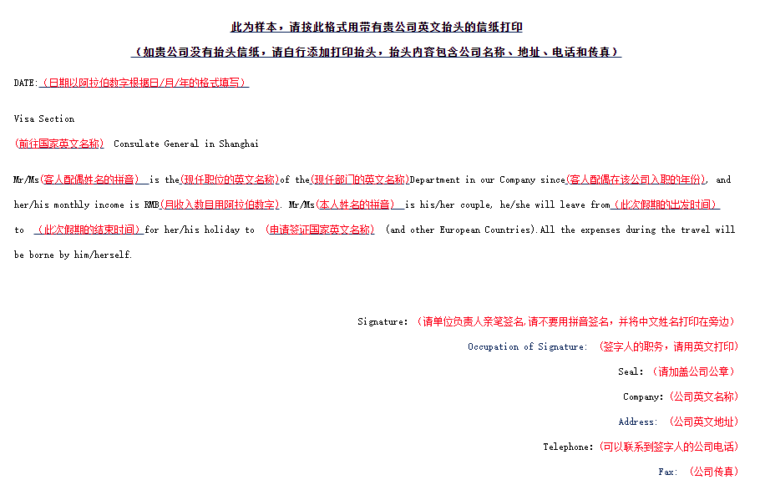
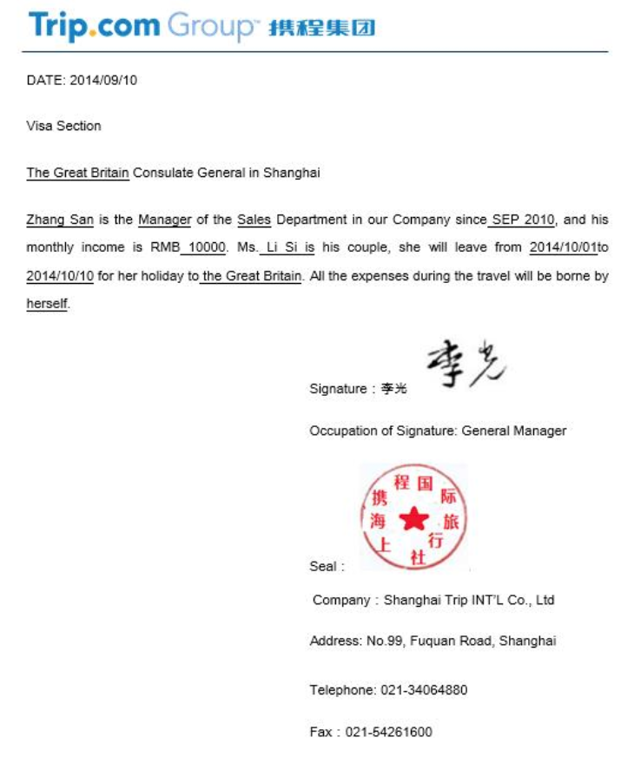
此为模板，请按此格式用带有贵公司抬头的信纸打印
（如贵公司没有抬头信纸，请自行添加打印抬头，空格处也需用打印的形式填写）
DATE:
Visa Section
Consulate General in Shanghai
________ is the _________of the ________Department in our Company since , and her/his monthly income is RMB . Mr/Ms is his/her couple, he/she will leave from to for her/his holiday to (and other European Countries如不去请将括号内话述删除). All the expenses during the travel will be borne by him/herself.

Signature：
Occupation of Signature:
Company：
Address:
Tel：
Fax:

