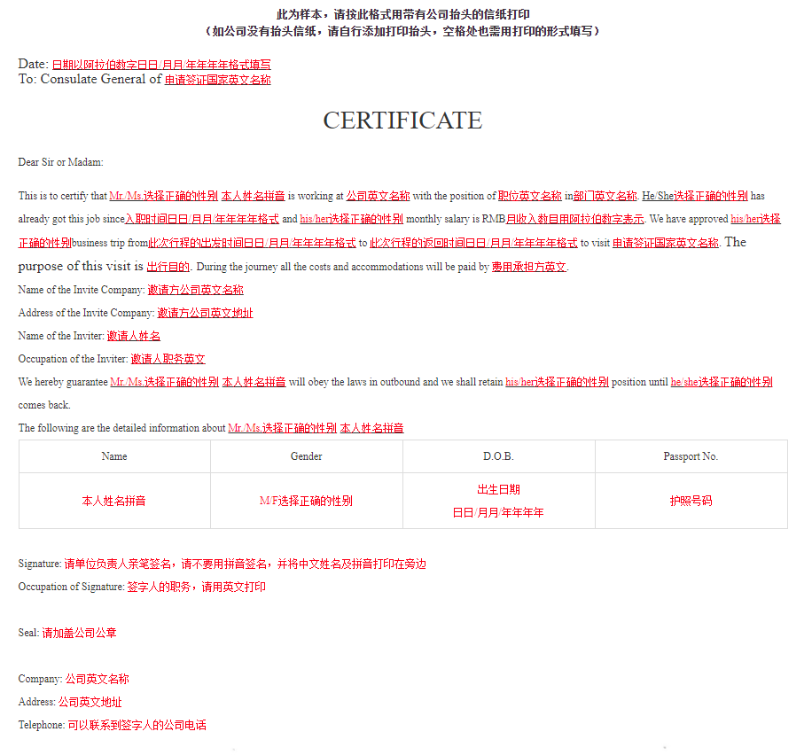
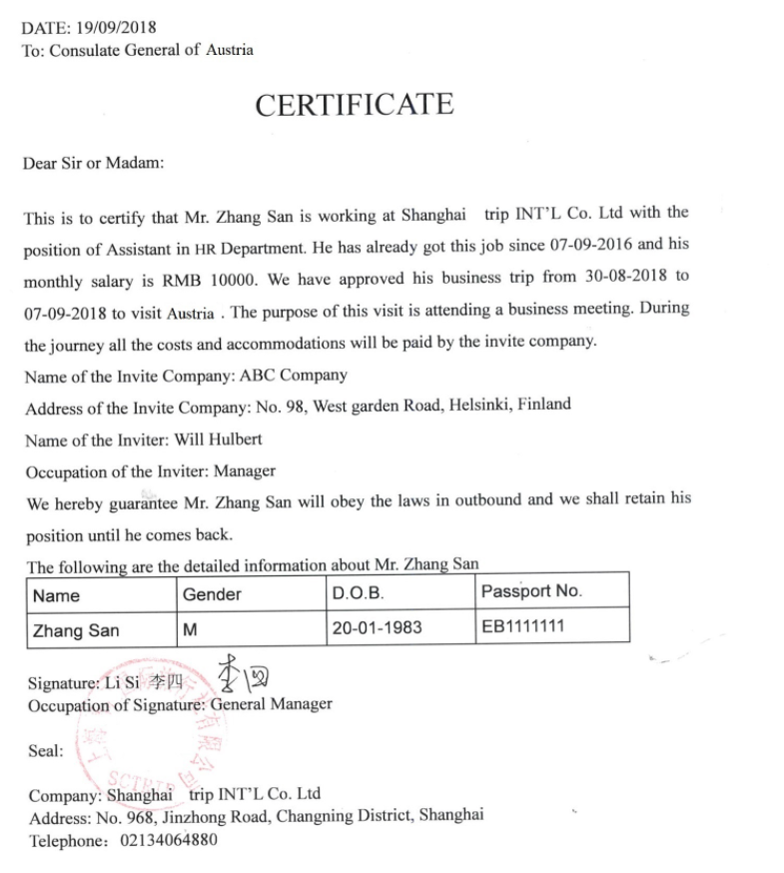
此为模板，请按此格式用带有公司抬头的信纸打印
（如公司没有抬头信纸，请自行添加打印抬头，空格处也需用打印的形式填写）

Date:
To: Consulate General of ________

CERTIFICATE

Dear Sir or Madam:

This is to certify that Mr./Ms.___________ is working at __________ with the position of ________ in _________. He/She_has already got this job since _________ and his/her monthly salary is RMB ______. We have approved his/her business trip from ___________ to ___________ to visit________. The purpose of this visit is_____________. During the journey all the costs and accommodations will be paid by___________.
Name of the Invite Company: ___________________
Address of the Invite Company: ________________________________
Name of the Inviter: ____________
Occupation of the Inviter: _______________
We hereby guarantee Mr./Ms.___________ will obey the laws in outbound and we shall retain his/her position until he/she comes back.
The following are the detailed information about Mr./Ms.___________
Name | Gender | D.O.B. | Passport No.

Signature:
Occupation of Signature:

Seal:

Company:
Address:
Telephone:

