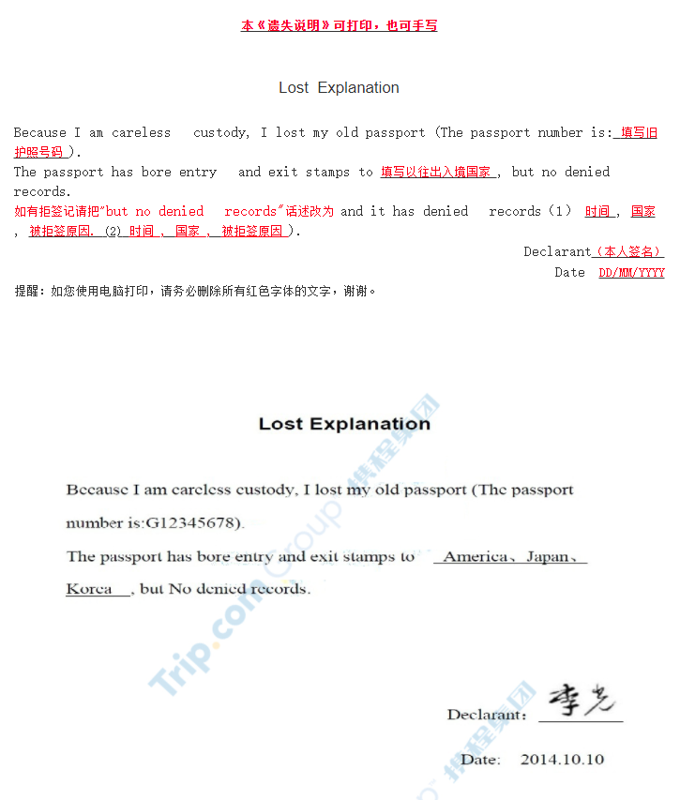
Lost Explanation

Because I am careless custody, I lost my old passport (The passport number is: ).
The passport has bore entry and exit stamps to , but No denied records.
(and it has denied records: , , ).

Declarant：

Date:

