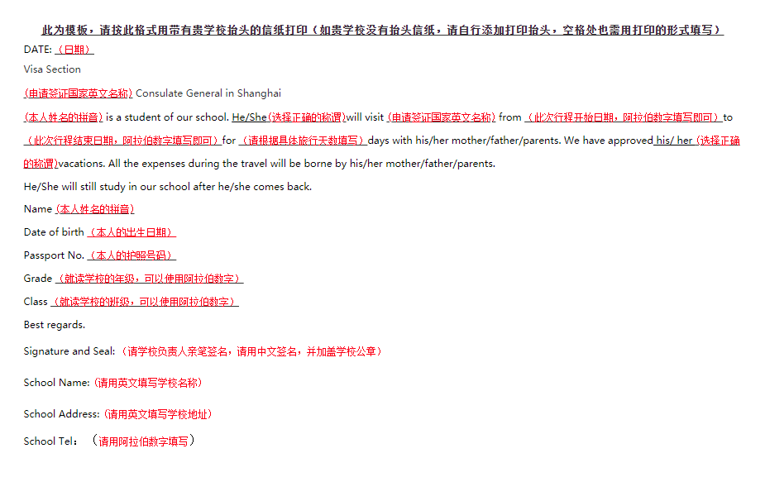
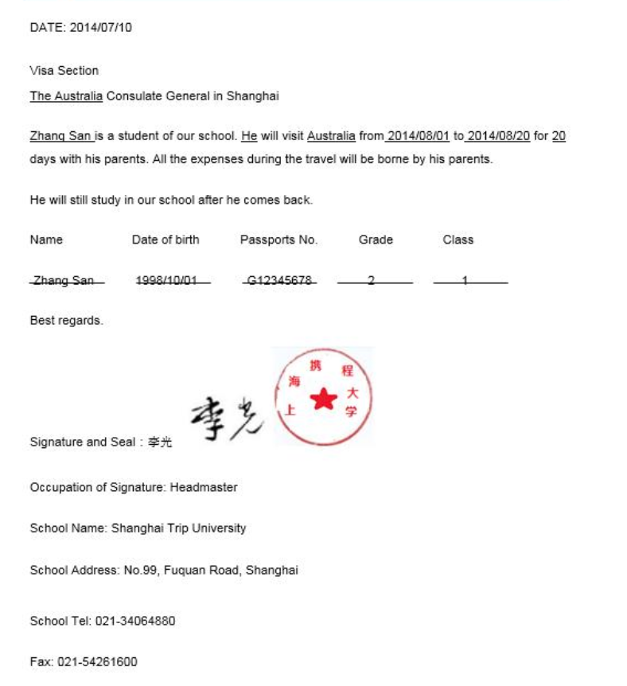
此为模板，请按此格式用带有贵学校抬头的信纸打印
（如贵学校没有抬头信纸，请自行添加打印抬头，空格处也需用打印的形式填写）
DATE:
Visa Section
Consulate General in Shanghai
is a student of our school. He/ She will visit from to
for days with his/her mother/father/parents. We have approved his/her vacations. All the expenses during the travel will be borne by his/her mother/father/parents.
He/She will still study in our school after he/she comes back.
Name Date of birth Passports No. Grade Class

Best regards.
Signature and Seal：
Occupation of Signature:
School Name:
School Address:
Tel:
Fax:

