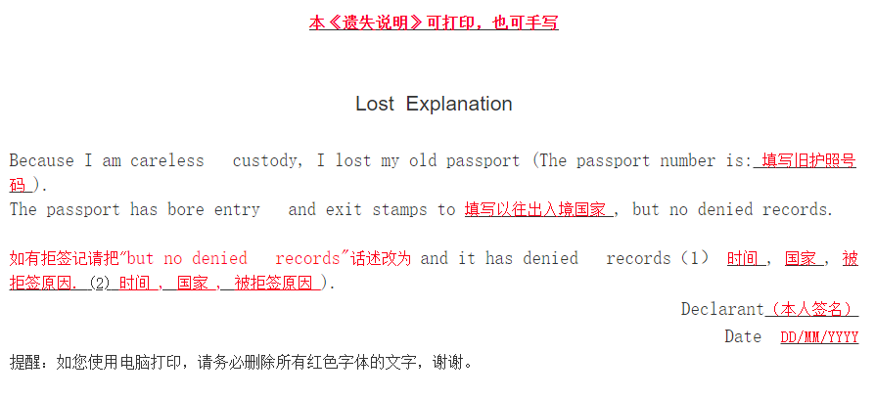
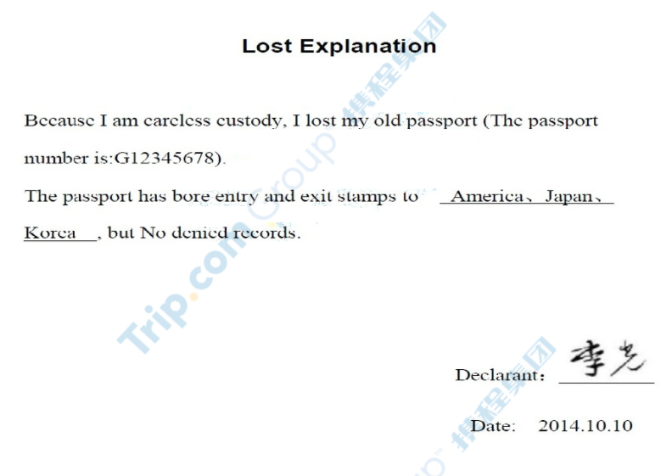

Lost Explanation

I had lost my for my carelessness.
Hereby declared.

Declarant：

Date:

