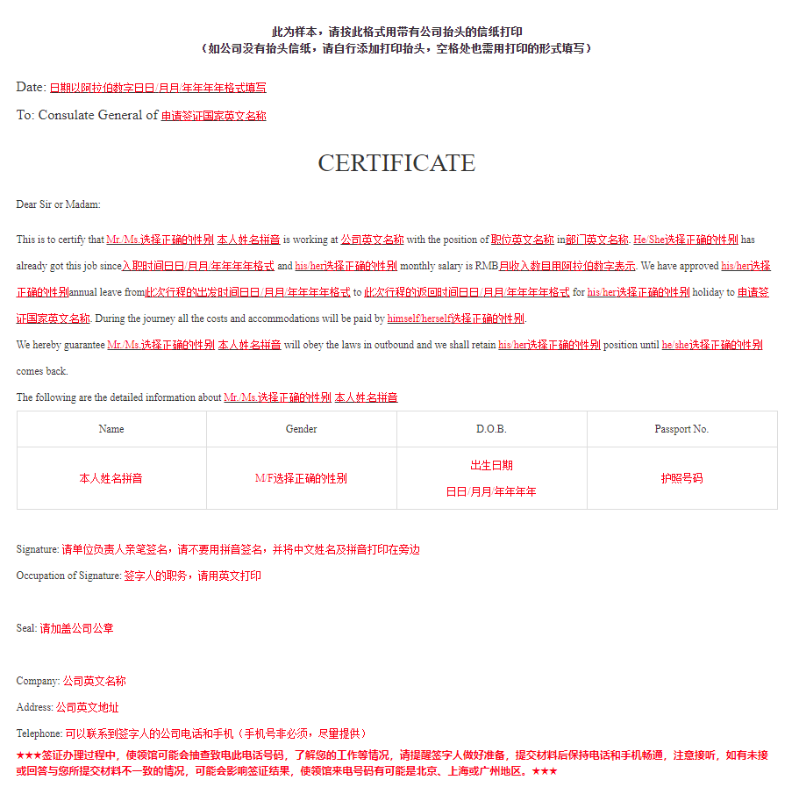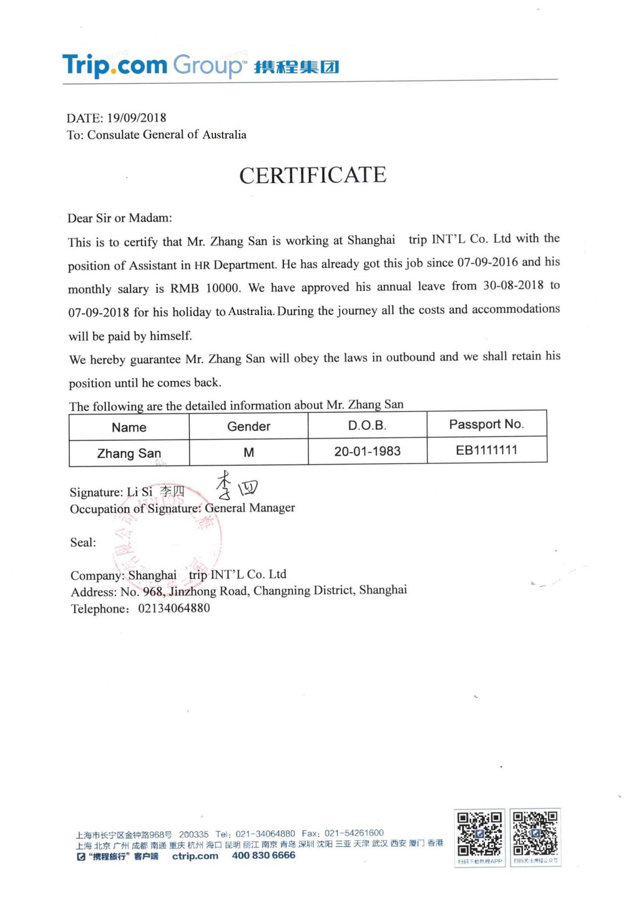

**此为模板，请按此格式用带有公司抬头的信纸打印**

**（如公司没有抬头信纸，请自行添加打印抬头，空格处也需用打印的形式填写）**

Date:

To: Consulate General of ________

CERTIFICATE

Dear Sir or Madam:

This is to certify that Mr./Ms.___________ is working at __________ with the position of ________ in _________. He/She has already got this job since _________ and his/her monthly salary is RMB ______. We have approved his/her annual leave from ___________ to ___________ for his/her holiday to ________. During the journey all the costs and accommodations will be paid by___________.

We hereby guarantee Mr./Ms.___________ will obey the laws in outbound and we shall retain his/her position until he/she comes back.

The following are the detailed information about Mr./Ms.___________

|  |  |  |  |
| --- | --- | --- | --- |
| Name | Gender | D.O.B. | Passport No. |
|  |  |  |  |

Signature:

Occupation of Signature:

Seal:

Company:

Address:

Telephone: