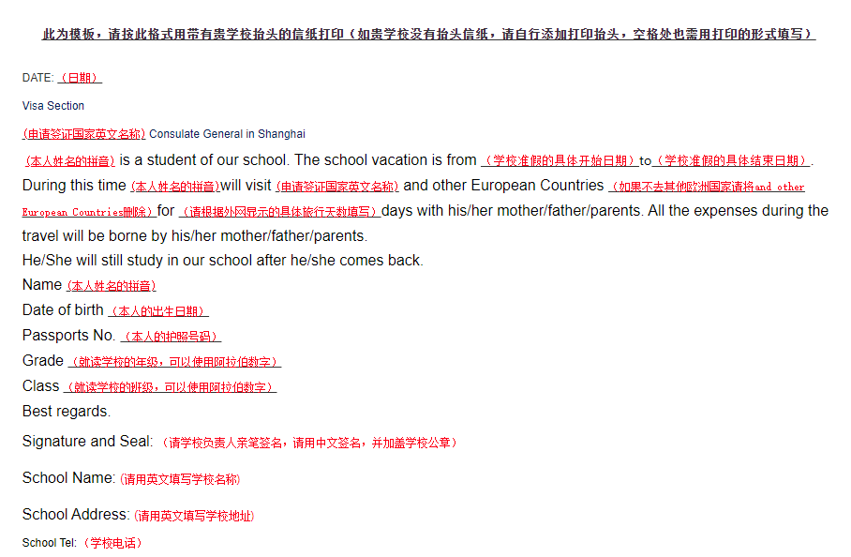
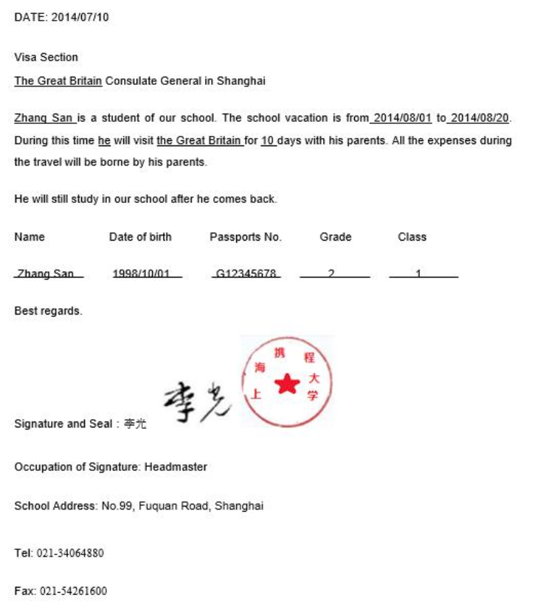
此为模板，请按此格式用带有贵学校抬头的信纸打印
（如贵学校没有抬头信纸，请自行添加打印抬头，空格处也需用打印的形式填写）
DATE:
Visa Section
Consulate General in Shanghai

is a student of our school. The school vacation is from to . During this time will visit and other European Countries （如果不去其他欧洲国家请将and other European Countries删除） for days with his/her mother/father/parents. All the expenses during the travel will be borne by his/her mother/father/parents.
He/She will still study in our school after he/she comes back.
Name Date of birth Passports No. Grade Class

Best regards.
Signature and Seal：
Occupation of Signature:
School Address:
Tel:
Fax:

